PIR Sensor Module (ROHS) - APS003

General Description

The PIR Sensor Module is a passive infrared sensor designed to pick up heat radiation of wave lengths in a band around 10 microns. It contains two active elements configured as balanced differential series opposed type. This results in good compensation of environmental temperature and excellent sensitivity for small changes of a spatial temperature pattern. Thermal signals far below one microwatt are sufficient to trigger a sufficient output voltage change.

Functional Description

If the active elements of the PIR sensor are exposed to a change in the surrounding temperature field, electrical charges are separated within the sensor elements. The voltage across the sensors controls a J-FET source follower impedance converter and thus modulates the output current of the PIR detector.
The spectral sensitivity of the sensor is controlled by the optical transfer characteristics of the window in the case and has been optimized to pick up radiation of the human body.

Applications

. Ηuman body detection
. Alarm systems
. Consumer electronics
. Automatic switches

Operating Conditions

Operating Temperature 0 °C to +70 °C
Storage Temperature 0 °C to +80 °C
Operating Voltage 6.2 to 14V

Electrical and Optical Characteristics

Test Conditions: VCC = 12.0V (Standby)
Symbol | Min | Type | Max | Unit
VCC | 6.5 | 12 | 14 | V
Idd |  | 8 |  | mA
Pulse width | 10 |  | 2046 | Sec

Output Conditions

. Two Output signal
-. One LED Drive (Can use TTL signal Low Active)
-. One TTL Signal (High Active), (Open Collector Output Max 50mA)

Fresnel lens Descriptions

Specification: 24 X24mm
Induction angle: 100
Induction distance: over 7M

Remark

Circuit stability time: 30s max.
While the circuitry is stabilizing after the power is turned on, the sensor output is not fixed in the “High” state or “Low” state. This is true regardless of whether or not the sensor has detected anything.

General note

Due to the high sensitivity of PIR sensor device, it is not recommended to use the module in the following or similar condition.
- In rapid environmental changes
- In strong shock or vibration
- In a place where there are obstruction material(eg, glass)through which IR cannot pass within detection area
- Exposed to direct sun light
- Exposed to direct wind from a heater or air condition

Connection Description

Assemble PCB layout

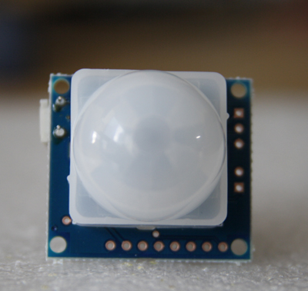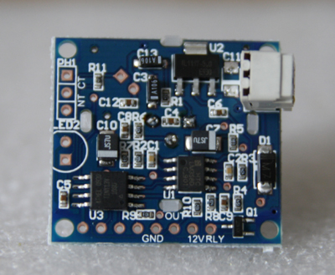

Ariel International Co., Ltd.
#404 Ssangyong Platinum 1445-13
Seocho-dong Seocho-gu Seoul
South Korea (137-866)
Tel: 82-2-522-0681, Fax: 82-2-522-0685, Mobile: 82-10-5274-4053
www.arielworld.kr

